Modified mini-open Transforaminal Lumbar Interbody Fusion
Ahmed Kamal Abdelhameid¹, Ahmed Saro², Yasser Elbanna³
Department of neurosurgery, Sohag university^{1, 2}, Alexandria university³
Background:
The paraspinal posterior approach to the lumbar spine initially was described for spinal fusion, particularly for the treatment of lumbosacral spondylolisthesis. Wiltse described his approach for lower lumbar and sacral vertebrae by bilateral incisions 4.5 cm lateral to the mid-line going through the natural cleavage plane between the multifidus part of sacrospinalis and the longissimus part. This will carry minimal postoperative back pain with low risk of infection.
Purpose:
We aim in this study to evaluate the modification of the Wiltse approach with its minimal intraoperative blood loss and minimal post-operative complication to be the approach of choice in the management of single level lumbar spine degenerative diseases.
Study design:
A retrospective study was done in the neurosurgical department at Sohag university hospital on 30 patients between January 2016 and January 2018. Visual analogue scale (VAS) and Quebec disability scale used for post-operative evaluation.
In this study a modification to this approach by single midline skin incision from 3- 5 cm with paraspinal dissection in the same plane described by Wiltse to get access to the transverse process and facet joints with minimal soft tissue dissection and retraction. This is less vascular than the mid-line approach, resulting in less bleeding and less post-operative back pain.
Methods:
Thirty patients with different lumber spine pathologies were operated via modified Wiltse approach by single midline skin incision from 3- 5 cm with paraspinal dissection in the natural plane of the sacrospinalis muscle between the longissimus and multifidus to get access to the transverse process and facet joints with minimal soft tissue dissection and retraction. Unilateral or bilateral facetectomy was done to achieve a good posterior decompression with transpedicular screws and interbody fusion. Patients were followed by complete pre and post-operative neurological assessment. Early and late postoperative complications were recorded. Radiographic follow-up for evaluation of fusion, and evaluating the operative results using both Visual analogue scale (VAS) and Quebec disability scale were done.
Results:
Males were more predominant in this study (60%) with average age 35.36±5.96 years back pain was the most frequent complain (100%) followed by sciatic pain (56%). Pars defect was presented in 17 cases (56.6%). L5-S1 affection was in (63.3%). The low back pain was improved after surgery in all cases. Post-operative hospital stay was average two days. One case presented by postoperative infection (3.3%). Dural tear with postoperative CSF leak was noticed in one patient. Neither complications related to the interbody cage nor screws were observed.
Conclusion:
Mini -open transforaminal lumbar interbody fusion approach provides a low- risk surgery, less intraoperative blood loss, and rapid postoperative recovery with favorable outcome in the management of single -level lumbar spine degenerative diseases.
Keywords:
Wiltse approach-Quebec scale-Visual analogue pain scale-interbody fusion

Introduction
The traditional spinal lumbar fusion surgery with its posterior midline approach to the lumbar spine requires aggressive dissection and complete separation of the paraspinal muscles from the spinous processes and the lamina. The result of this aggressiveness, could easily affect badly the posteromedial branches of the spinal nerves as well as the descending posterior lumbar artery branches. ^{7,9,17}
The Long time overstretching of the paraspinal muscles during the fixation surgery by the self-retaining retractors to reach the entry point of the transpedicular screws and to expose the transverse process, could result in atrophy and ischemic changes of the paraspinal muscles that affect the healing power, giving a chance for post-operative muscle necrosis and infection. Postoperative flat back deformity and intractable chronic pain commonly are seen. ^{3, 6}
Spine surgeons described different approaches to spinal surgery aiming at reducing the aggressiveness of the traditional posterior midline surgical approach. In 1968, Leon Wiltse described a new approach that carries a minimal invasive surgery for the lumber spine using a two paramedian skin incision and going through the sacrospinalis muscle dissection on each side to reach the facet and the transverse process. This surgical approach associated with less intraoperative bleeding, avoidance the over-stretch of the muscle, hence, less ischemic changes to the paraspinal muscles and less postoperative pain. These lower morbidity factors gave the Wiltse approach the chance to be an alternative surgery in the lumber spine. ^{15, 22}
Wiltse thought that his approach has the advance to be safest direct route to the facet joints and the transverse process (site of screw entry) in the lumber spine with minimal tissue damage and less bleeding than the posterior midline approaches. He described that the sacrospinalis muscle fibers split about two-ﬁnger breadths lateral to the midline and at this level, its fibers run in various directions. Based on cadaveric dissection studies, Vialle et al in 2006 described that there is a natural cleavage plane of the sacrospinalis muscle between the multifidus and the longissimus parts of the sacrospinalis muscle. Hence, he described a term of “modiﬁed muscle-sparing approach,” where this natural plane became the landmark for dissection by using a Langenbeck elevator to gently pull the ﬁbers of the multiﬁdus medially so this cleavage plane can be clearly visualized. ^{1, 21}
In this study, we aimed at modulation of the Wiltse approach by a single small midline skin incision and dissection gently through the natural plane described by Vialle, 3-5 cm lateral to the midline on each side with insertion of transpedicular screws and interbody fusion to replace the traditional midline aggressive surgery in cases with pars defect or single level lumber disc prolapse.
Patient and Methods:-
In a retrospective study at neurosurgery department Sohag faculty of medicine, Between January 2016 and January 2018, 30 patients with different lumbosacral spine pathological degenerative diseases underwent modified mini open transforaminal lumber interbody fusion.
We included in our study patients with:
- Single level lumbar (central & paramedian) disc prolapse
- Single level far lateral disc
- Pars defect
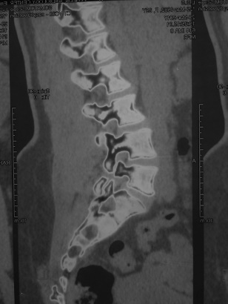
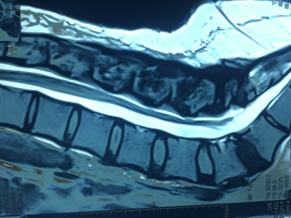

Fig 1. CT and MRI lumbosacral spine showing bilateral fracture pars

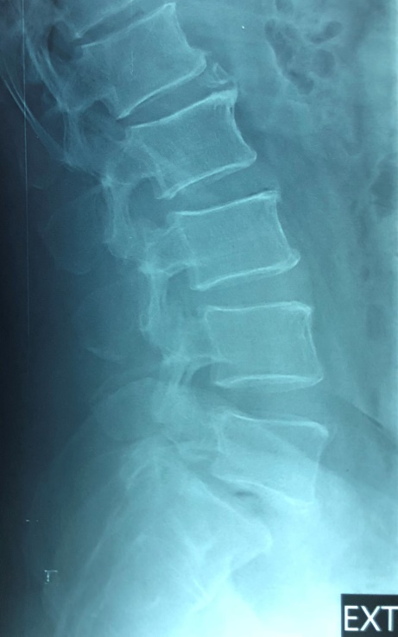

Fig 2. Plain X-ray lateral film showing spodylolithesis L5-S1
We excluded in our study patients with
- More than one level lumber disc prolapse
- Grade III or IV spodylolithesis
- Canal stenosis with ligamentous flavum hypertrophy
- Previous spine surgery
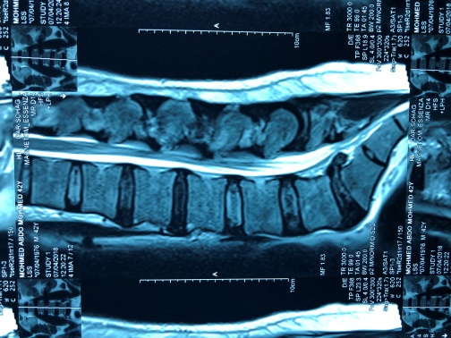
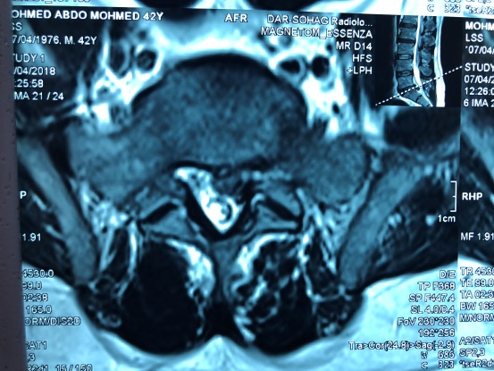

Fig 3. MRI lumbosacral spine showing herniated disc on the Lt. Side without ligamentum flavum hypertrophy
A preoperative neurological assessment, full laboratory investigations and medical examination were done. We used the Visual pain analogue scale ² (Fig 1) and Quebec scale to assess the patients’ improvement regarding pain¹¹ (Fig 2).
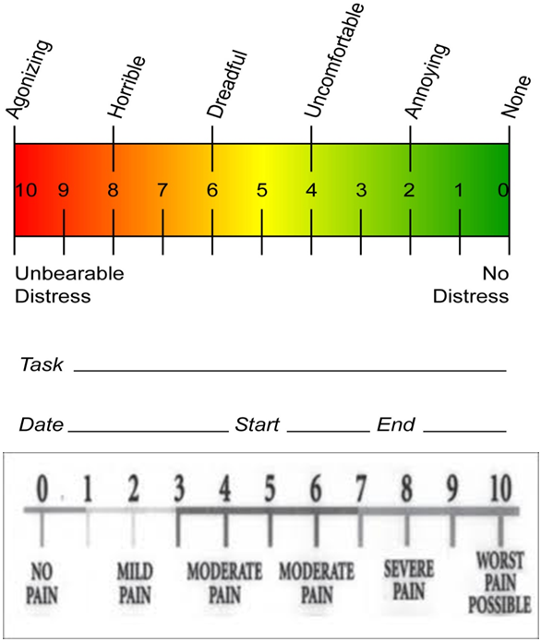
Fig 4. Visual analogue pain scale (VAPS) ²
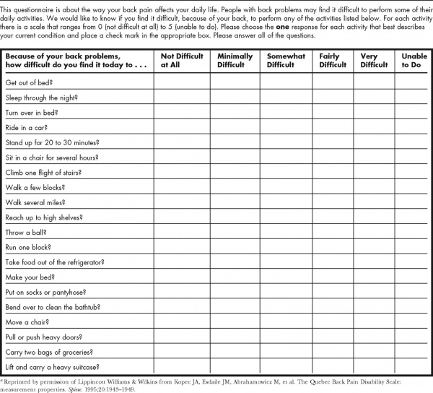

Fig (5) Quebec Scale¹¹
Operative Technique
After a fully informed written consent, and under general anesthesia, our patients were placed prone in radiolucent spine frame which allows for intraoperative AP and lateral imaging by C-arm. Ensuring the level site using the intraoperative fluoroscopy, standard small midline posterior skin incision is done, 3-5cm lateral to the midline on each side could be the natural plan of dissecting fibers of the sacrospinalis muscle.
Gently dissection between the multifidus and longissimus parts of the sacrospinalis muscle without damage of the muscle fibers or its blood supply. First, we dissect the side of no complaint in cases presenting by sciatica with prolapsed lumber disc (the contralateral side of disc herniation and foraminal stenosis). 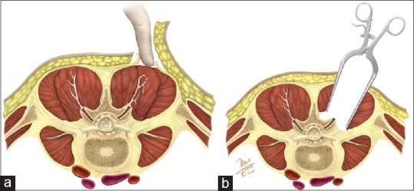
Fig 6. ⁸ (a) The drawing depicts in A after the fascial opening the digital location of the intermuscular plane: the multifidus is medially located, the longissimus is lateral. (b) The Meyerding retractors are placed in the deep plane, the area where the joint facet and the transverse process meeting is exposed.
After we reach the facet joint and the transverse process, we used the bipolar diathermy to skeletonize the entry point of our transpedicular screws. We used polyaxial screws with 6.5*45 in lumber vertebra or 6.5*40 in S1. A suitable road size was selected and placed with slight distraction and the screws were tightened.
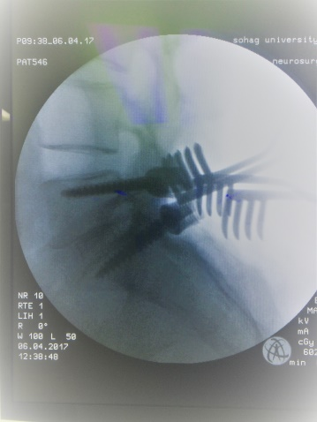

Fig 7. Intra-operative fluoroscopy shows placing of the screws with the use of small self-retaining retractors.
Dissection on the same natural plane of the sacrospinalis muscle in the opposite side was done. Facetectomy at this side should be carried out with discectomy after exploration of the nerve root. Transpedicular screws at this side were put together with interbody fusion. We used iliac bone graft and peek or titanium cage for the interbody fusion.
We loosened the screws of the first rod of the contralateral side, then we placed the second rod of the same side, compression with tightening the screws with torque and anti-torque was done.
In cases of pars defect bilaterally with spodylolithesis reduction was done using reduction screws. We used one gram vancomycine powder as a local antibiotic with closure of the sheath at the site of natural plane dissection. We closed the wound without using a suction drain.
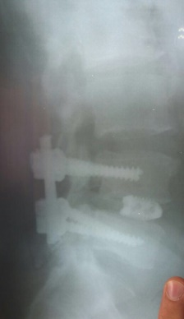
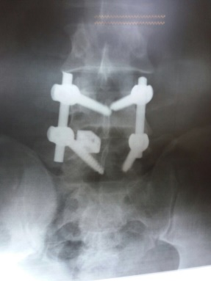

Fig 8. Post-operative AP and lateral lumbosacral x-ray showing the screws and the interbody fusion leaving the lamina
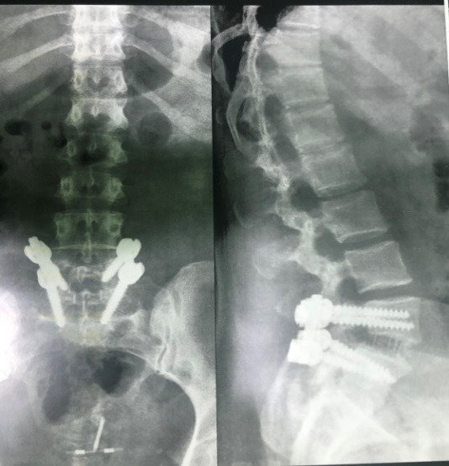

Fig 9. Twelve months follow up lumbosacral X-ray of female patient after interbody fusion of pars defect
Post-operative lumbosacral x-rays were done for all cases, follow up period ranged from 6 months to 1 year with an average 9 months.
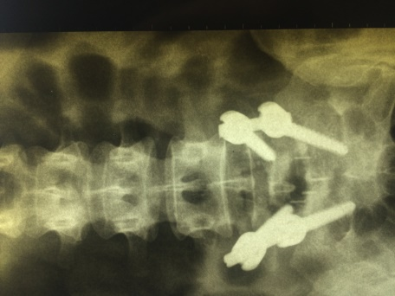
Fig 10. Post operative lumbosacral x-ray showing fixation of L5-S1 leaving the lamina intact with interbody fusion.
Statistical analysis
Data was analyzed using Microsoft Excel 2016 (Microsoft corporation, USA) and SPSS version 24 (May 2016, IBM corporation, USA). Qualitative data was presented as numbers and percentages; while quantitative data were presented as mean and standard deviation. Comparison between pre and postoperative data regarding Quebec scale and visual analog pain scale was done using paired t test. P value of less than 0.05 was considered as significant.
Results
Thirty patients with different lumbosacral spine pathological lesions with predominance of male ratio (table 1).
Table 1. Gender distribution
Male | 18 patients | 60%
Female | 12 patients | 40%
Our patient's age ranged from 21-55 years with a mean of 35.36±5.96 years. In our study, fracture pars were more predominant, accounts for 17 cases. On the other hand the prolapsed lumber discs (PLD) were found only 13 cases (table 2).

Table 2. Pathological cause
Site | Number of cases | Percentage
Pars defect | 17 cases | 56.6%
PLD | 13 cases | 43.3%
Among seventeen cases with pars defect, three of them were with spodylolithesis grade I and two with spodylolithesis grade II. L5-S1level was the most predominant (63.3%) than L4-5 in our study.
Table 3. Pathological level
Site | Number of cases | Percentage
L4-5 | 11 cases | 36.7%
L5-S1 | 19 cases | 63.3%
Back pain was the main complaint for all of our patients and we use the visual analogue pain scale and the Quebec Back Pain Disability Scale for pre and post-operative assessment (table 4 and Fig. 11).
Table 4. Improvement regarding pain using Quebec scale
Pre-operative
Quebec scale | No. of patients | No. of patients
Severe (98-80) | 19 | 2
Moderate (40-79) | 9 | 10
Below 40 | 2 | 18
Paired t test = 8.742, p value <0.001 (highly significant)

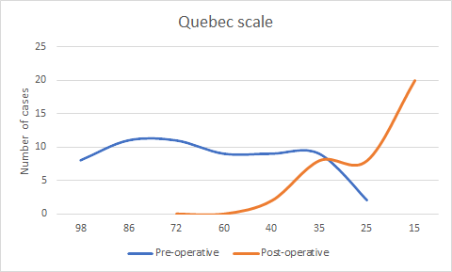

Fig 11. Improvement in Quebec scale

Table 5. Improvement regarding visual analogue pain scale
Pre-operative |  | Post-operative
VAPS | No. of patients | VAPS | No. of patients
8-10 | 19 | 8-10 | 0
5-7 | 11 | 5-7 | 0
3-4 | 0 | 3-4 | 8
0-2 | 0 | 0-2 | 22
P value <0.001 (highly significant)
In seventeen patients, back pain was associated with sciatic pain and positive straight raising test. Three patients showed partial foot drop which improved in the follow up. No patients in our series presented by sphencteric dysfunction (Table 6).
Table 6. Clinical presentation
Symptoms and signs | No. of patients | Percentage
Back pain | 30 | 100%
Sciatica | 17 | 56.6%
Positive straight raising test | 17 | 56.6%
Partial foot drop | 3 | 10%
Sphencteric dysfunction | 0 | 0.0%
In one case iatrogenic dural tear was happened, and repair was difficult as the tear was in the anterior dura during placing the cage. This patient presented by a post-operative CSF leak and stopped within 4 weeks after limitation of movement and medication by carbonic anhydrase inhibitors tablet (Cidamex). Superficial wound infection was noted in the same case which resolved with broad spectrum antibiotics and daily dressings (table 7).
Table 7. Postoperative complications
Post-operative Complications | No. of patients | Percentage
Dural tear | 1 | 3.3%
Superficial wound infection | 1 | 3.3%
CSF leak | 1 | 3.3%
Vascular Injury | 0 | 0.0%
Neurological deterioration | 0 | 0.0%

Fig 12. Post-operative complications
As regarding hospital stay, none of our patient stayed more than 72 hours in the hospital. Intraoperative blood loss does not exceeded 50-100 cc blood. Average time of surgery was about one and half hour.
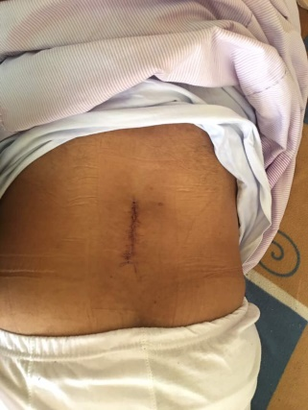

Fig 13. Follows up of a patient showing the small scar of surgery
Discussion
With the introduction of the microsurgery in 1988, Wiltse described the paraspinal approach for the lumbar spine surgery after reporting the paraspinal muscles’ damage in the traditional midline approach. Modification of Wiltse approach by working through the natural plane of the sacrospinalis muscle, considered a surgical option for lumbar foraminal and extraforaminal lesions with preservation of the paraspinal muscle integrity. In addition, safe placement of the transpedicular screws with medial angulation can be performed. Post-operative degeneration of the facet joint and adjacent segment disease was shown to be less frequent than the midline approach. The minimal invasive paraspinal approach (modified Wiltse), is a muscle sparing with low tissue damage and lower infection rate than the midline approach. ^{4, 10, 12,14,21,22}
This paraspinal approach found to have the benefits of Reducing the post- operative back pain due to less muscle manipulation, preservation of the neurovascular supply of the multifidus muscle and leaving the supraspinal and intraspinal ligament intact with no dead space that could cause infections. Additionally, it has a short surgical time, less post-operative hospital stay and preservation of the nerve of the medial dorsal branch and its transverse spinal and interspinal branches, with its superior and inferior anastomosis is achieved. ^{5,16,19,23}
Among our patients, we found one case (3.3%) that had a post-operative infection and this showed a similarity of the study done in a retrospective study established in 2016 by Street et al.¹⁸ In comparison with the midline approach, he reported a lower post-operative infection rate in the modified Wiltse (7.8% in midline versus 1% in paraspinal splitting), and less intraoperative bleeding (703 ml in the midline approach versus 336 ml in paraspinal splitting).
The increased amount of bleeding recorded in Street study in the paraspinal splitting approach, in comparison to our study (about 100 ml blood loss), may be due to patients’ selection which was done in our series for single level only. For a posterolateral fusion, it provides an excellent exposure of the transverse processes for applying bone graft while protecting the superior joint complex. The risk of adjacent segment failure in short posterior constructs is also lower in the Wiltse approach. ¹⁸
In 2013, Mukai and colleagues introduced a comparative study for the residual post-operative back pain between the conventional approach and the mini open approach in multiple level lumbar disc lesions. He found that there were no statistical significant differences between the two groups. The same results were found with the Buttermann and colleagues in 2015, they mentioned that the midline and paraspinal approaches have a similar outcome in two level spinal fusions. However, the study had a lower statistical power. ^{3, 13}
From 1993 to 2016, many authors described the advance of the mini-open muscle splitting approach for management of lumbar spine lesions and compare their results with the traditional midline approach. They approved the superiority of the mini open approach in management of single level lumbar spine degenerative diseases (Table 8).⁸
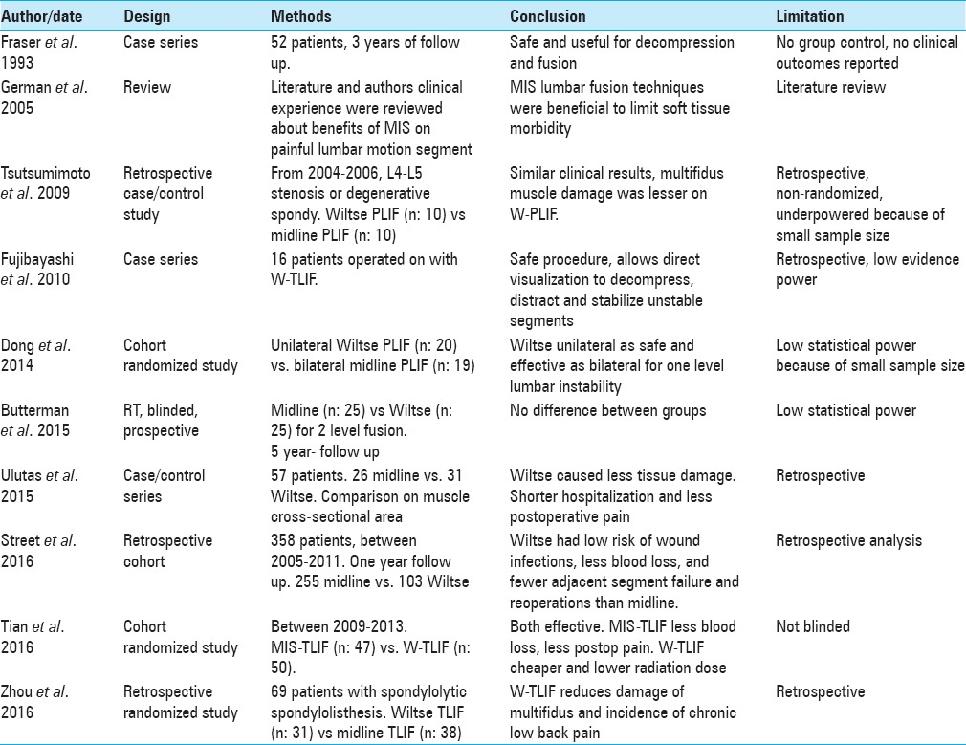
Table 8. Comparitive studies between the mini open approach and the traditional midline approach⁸
In spite of poor vision in the mini-open approach, dural tears are uncommon complication as the approach aiming to be lateral and away from the dural sac. Only one case in our study showed an axillary dural tear (3.3%). The highest incidence of iatrogenic dural tear was reported by Tsutsumimoto in 2009 was (5.7%).^{18, 20}
In our series, we instructed the patients to be supine for 24 hours after which they are allowed to sit on the bed. The mean time of the hospital stay was two days. Tsutsumimoto in 2009 and Street in 2016 agreed for the supine rest for 24 hours post-operative with an average 3 days hospital stay. ^{18, 20}
All previous studies described the use of prophylactic antibiotics and analgesia for 3 days due to the high risk of infection in our community. We used the post-operative prophylactic antibiotics for 15 days. After three days, kinesiotherapy was started, and the patient could resume his daily activities. Rehabilitation started in the second postoperative month, with exercises controlled by the physiotherapist. After the third month, the patient was referred to aerobics to start a supervised muscular recovery program. ^{8,17,18,20}
Conclusion:
Mini open transforaminal paraspinal splitting approach can be an alternative option for traditional midline approach in management of single level lumbar disc lesions with interbody fusion. It carries a less tissue damage, less intraoperative bleeding, less post-operative back pain, less hospital stay, and rapid recovery.
Abbreviations
PLD: Prolapsed lumbar disc
References:
- Anand N, Baron EM, Bray RS. Beneﬁts of the paraspinal muscle sparing approach versus the conventional midline approach for posterior nonfusion stabilization: Comparative analysis of clinical and functional outcomes. SAS Journal; 1(3):63-67, 2007.
- Bird SB, Dickson EW. Clinically significant changes in pain along the visual analog scale. Ann Emerg Med; 38(6):639-43, 2001.
- Buttermann GR, Mullin WJ: Two-level circumferential lumbar fusion comparing midline and paraspinal posterior approach: 5-year interim outcomes of a randomized, blinded, prospective study. J Spinal Disord Tech 28:E534–E543, 2015.
- Fan S, Hu Z, Fang X, Zhao F, Huang Y, Yu H. Comparison of paraspinal muscle injury in one level lumbar posterior interbody fusion: Modified minimally invasive and traditional open approaches. Orthop Surg; 2:194–200, 2010.
- Freudiger S, Dubois G, Lorrain M. Dynamic neutralisation of the lumbar spine confirmed on a new lumbar spine simulator in vitro. Arch Orthop Trauma Surg; 119(3-4):127–132, 1999.
- Gejo R, Kawaguchi Y, Kondoh T, Tabuchi E, Matsui H, Torii K, et al: Magnetic resonance imaging and histologic evidence of postoperative back muscle injury in rats. Spine (Phila Pa 1976) 25:941–946, 2000.
- German JW, Foley KT: Minimal access surgical techniques in the management of the painful lumbar motion segment. Spine (Phila Pa 1976) 30 (16 Suppl):S52–S59, 2005.
- Guiroy, A. Sícoli, N. Gonzalez Masanés, A. Morales Ciancio, M. Gagliardi, and A. Falavigna. How to perform the Wiltse posterolateral spinal approach: Technical note; Surg Neurol Int; 9: 38, 2018.
- Kawaguchi Y, Yabuki S, Styf J, Olmarker K, Rydevik B, Matsui H, et al: Back muscle injury after posterior lumbar spine surgery. Topographic evaluation of intramuscular pressure and blood flow in the porcine back muscle during surgery. Spine (Phila Pa 1976) 21:2683–2688, 1996.
- Kim, C.W. Scientific Basis of Minimally Invasive Spine Surgery: Prevention of Multifidus Muscle Injury during Posterior Lumbar Surgery. Spine (Phila Pa 1976), 35, S281-286, 2010.
- Kopec JA, Esdaile JM, Abrahamowicz M, Abenhaim L, Wood-Dauphinee S, Lamping DL, etal, The Quebec Back Pain Disability Scale. Measurement properties. Spine 20(3):341-52, 1995.
- Lee, S., Jahng, T. and Kim, H. Facet Joint Changes after Application of Lumbar Nonfusion Dynamic Stabilization. Neurosurgical Focus, 40, E6, 2016.
- Mukai Y, Takenaka S, Hosono N, Miwa T, Fuji T. Intramuscular pressure of the multifidus muscle and low-back pain after posterior lumbar interbody fusion: comparison of mini-open and conventional approaches. J Neurosurg Spine; 19(06):651–657, 2013.
- Ran B, Yan L, Cai L. Wiltse approach versus the conventional posterior midline approach for lumbar degenerative diseases: A meta-analysis. Zhong Nan Da Xue Xue Bao Yi Xue Ban; 40:90–101, 2015.
- Ray CD. The paralateral approach to decompression for lateral stenosis and far lateral lesions of the lumbar spine. Chapter 29. Lumbar Discectomy and Laminectomy. Edited by Watkins. Collins, Aspen Publishers; 217–227, 1987.
- Rodríguez-Vela J, Lobo-Escolar A, Joven-Aliaga E, et al. Perioperative and short-term advantages of mini-open approach for lumbar spinal fusion. Eur Spine J; 18(08):1194–1201, 2009.
- Spoor, A. and Oner, F. Minimally Invasive Spine Surgery in Chronic Low Back Pain Patients. Journal of Neurosurgical Sciences, 57, 203-218, 2013.
- Street J, Glennie A, Dea N, DiPaola C, Wang Z, Boyd M, et al. A comparison of the Wiltse versus midline approaches in degenerative conditions of the lumbar spine. J Neurosurg Spine; 25:332–8, 2016.
- Strempel AV, Moosmann D, Stoss C. Stabilization of the degenerated lumbar spine in the nonfusion technique with cosmic posterior dynamic system. WSJ; 1:40–47, 2006.
- Tsutsumimoto T, Shimogata M, Ohta H, and Misawa H. Mini-open versus conventional open posterior lumbar interbody fusion for the treatment of lumbar degenerative spondylolisthesis: comparison of paraspinal muscle damage and slip reduction. Spine;34(18):1923–1928, 2009
- Vialle, R., Wicart, P., Drain, O., Dubousset, J. and Court, C. The Wiltse Paraspinal Approach to the Lumbar Spine Revisited: An Anatomic Study. Clinical Orthopedics and Related Research, 445, 175-180, 2006.
- Wiltse, L.L. The Paraspinal Sacrospinalis-Splitting Approach to the Lumbar Spine. Clinical Orthopedics and Related Research, No. 91, 48-5, 1973.
- Wrugler-Hauri CC, Kalbarczyk A, Wiesli M, Landolt H, Fandino J. Dynamic neutralization of the lumbar spine after microsurgical decompression in acquired lumbar spinal stenosis and segmental instability. Spine; 33(09):1050, 2008.

الملخص العربى
استخدام طريقة ويلسي بالتدخل المحدود في تثبيت الفقرات
مقدمة البحث
ان التدخلات الجراحية المعتادة باستخدام التقنية للفتح الاوسط الخلفى فى حالات الانزلاق الغضروفى القطنى او التزحلق الفقارى للفقرات القطنية يقابله العديد من المضاعفات سواء اثناء التدخل الجراحى او ما بعد التدخلات الجراحية. فى عام 1987 جاء العالم ويلسى لعمل تقنية جراحية محدودة التدخل بدون التعرض للعضلات مما يققل الضرر الناتج من تهتك العضلات والانسجة كما يقلل النزيف المتوقع اثناء التدخل الجراحى. استحدث تعديل من قبل الجراحين على طريقة ويلسى ليقضوا على العيب بوجود جرحين بأسفل الظهر من الخلف واستبداله بجرخ واحد مع البقاء على محدودية التدخل بين العضلات لاستئصال الغضروف وتثبيت الفقرات القطنية من الخلف.
الغرض من البحث
تقييم مدى فعالية طريقة ويلسي لتثبيت الفقرات القطنية العجزية فيما يخص تقليل درجة الالم
تصميم البحث
دراسة مرجعية قامت في مستشفى سوهاج الجامعي خلال سنتين ما بين يناير2016 ويناير2018 بقسم جراحة المخ والاعصاب المستشفى الجامعى وتشمل مرضى الانزلاق الغضروفي.
طريقة البحث
تمت هذه الدراسة على عدد 30 مريض يعانون من انزلاق غضروفى قطنى او تزحلق فقارى من الدرجة الاولى والثانية. وتم عمل فحص كامل مع الاشعات على العمود الفقارى واستخدام الاستحداث فى طريق ويلسى لتثبيت الفقرات القطنية مع وضع قفص كربونى عوضا للغضروف المستأصل. تمت متابعة المرضى باستخدام مقياس كيوبيك ومقياس الألم الطولى لمعرفة درجة التحسن.
نتائج البحث
أوضحت النتائج تحسن المرضى من ألام اسفل الظهر مع الاطراف السفليةز كما اوضحت قلة نسب الاصابة بالالتهابات ما بعد التدخل الجراحى وقلة احتياج المرضى لعدد ايام أكثر للنقاهه والعودة سريعا للخياة الطبيعية.
ملخص البحث
ان التدخل المحدود باستخدام الاستحداث لتقنية ويلسى قد يكون بديلا للتدخل الجراحى القديم لعلاج حالات النزلاق الغضروفى القطنى او التزحلق الفقارى للفقرات القطنية.

